Practical 9 :

Code :

 class Hello {

    public static void main(String[] args) {

        double d = 99.0d;

        byte b = (byte)d;

        System.out.println("The value of double d is "+d);

        System.out.println("The value of byte b after Explicit typecasting  is "+b);

    }

}

Output :

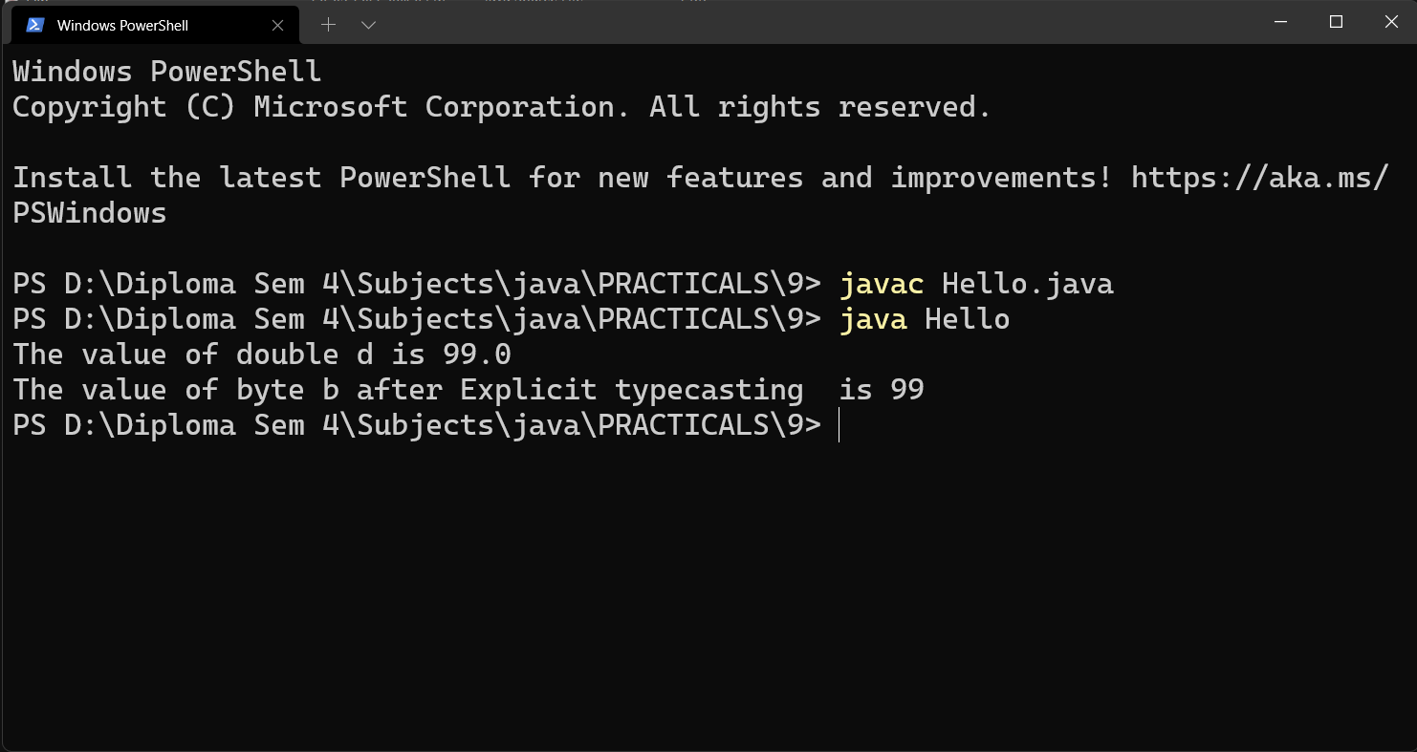

Code :

class Exp {

    public static void main(String[] args) {

       double d = 87.0d;

       float f = (float)d;

       long l = (long)f;

       int i =(int)l;

       short s = (short)i;

       byte b = (byte)s;

       //double e =(57\*4)+(500/'z')-(0.124\*102);

       System.out.println("The value of double     : "+d);

       System.out.println("The value of float      : "+f);

       System.out.println("The value of long       : "+l);

       System.out.println("The value of int        : "+i);

       System.out.println("The value of short      : "+s);

       System.out.println("The value of byte       : "+b);  }

}

Output :

